**ASSIGNMENT - I**

1. **Create a database called COMPANY consisting of two tables - EMP & DEPT**

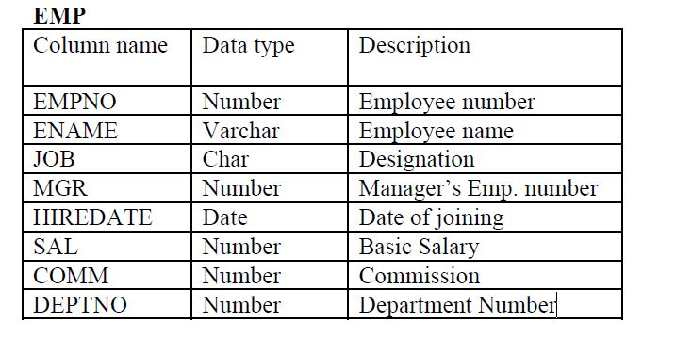

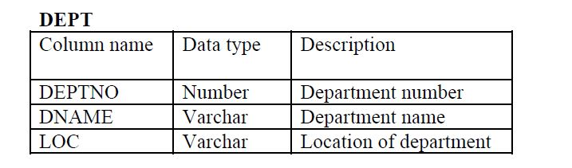

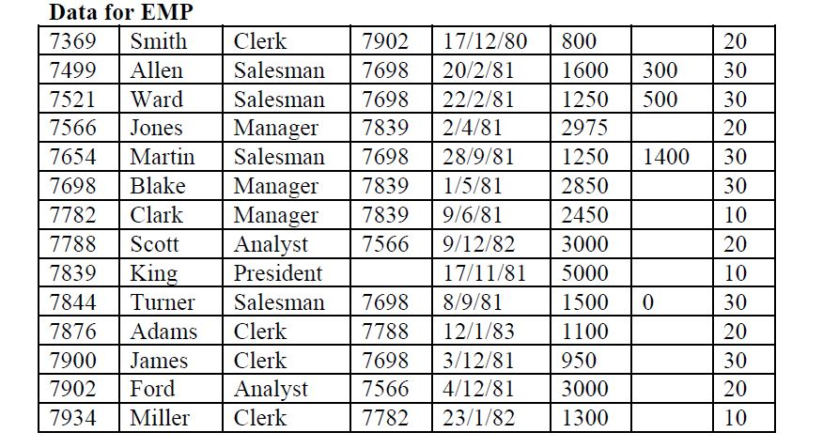

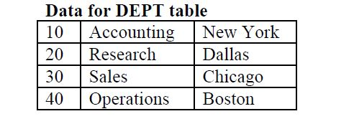

2. **Perform the following queries on the tables just created :**

1. List the names of analysts and salesmen.

2. List details of employees who have joined before 30 Sep 81.

3. List names of employees who are not managers.

4. List the names of employees whose employee numbers are 7369, 7521, 7839,

7934, 7788.

5. List employees not belonging to department 30, 40, or 10.

6. List employee names for those who have joined between 30 June and 31 Dec. ‘81.

7. List the different designations in the company.

8. List the names of employees who are not eligible for commission.

9. List the name and designation of the employee who does not report to anybody.

10. List the employees not assigned to any department.

11. List the employees who are eligible for commission.

12. List employees house names either start or end with “S”.

13. List names of employees whose names have “i” as the second character.

14. List the number of employees working with the company.

15. List the number of designations available in the EMP table.

16. List the total salaries paid to the employees.

17. List the maximum, minimum and average salary in the company.

18. List the maximum salary paid to a salesman.